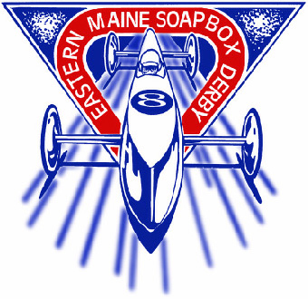
EASTERN MAINE SOAP BOX DERBY

Awarded “OUTSTANDING RACE CITY 1998, 2003 & 2007”
By the All-American Soap Box Derby

REGISTRATION / LIABILITY RELEASE FORM—2009
14th ANNUAL - RACE DATE: May 30, 2009

Age Requirements for 2009: You must be the minimum age of the
Stock Division - ages 8 - 13 division by the race date of May 30, 2009,
Super Stock Division - ages 10 - 17 and cannot exceed the maximum age of
Masters Division - ages 10 - 17 the division before July 25, 2009.

There is a non-refundable $35 fee (due at registration). Register early - Registration deadline is May 9 and space is limited. For information call 992-4490.

Participant’s Name_____________________________________ Age____ Date of Birth________________

Address______________________________________ City ____________________ Zip code____________

Male___ Female____ T-Shirt Size: (Youth Sm __ Md __ Lg __) (Adult Sm __ Md __ Lg __ )
Division: Stock___ Super Stock___ Masters___ Do you have a car? Yes / No - If yes, car #? ________

Have you participated in a Soap Box Derby Race before? Yes / No

Parent/Guardian Name: _____________________________________ Phone Number_________________

Parent e-mail ________________________________ Racer e-mail _________________________________

If using a car formally used by another racer, the car must be rebuilt by the new driver.
Is your car Sponsored? Yes / No If yes, Sponsor(s) name(s) (may be more than one Sponsor)
_________________________________________________________________________________________
There is a $ 50 Sponsor per derby car due by May 1st 2009 for cars sponsored by a business.
(Non Profit Organizations are exempt) Do you want us to bill them directly? Yes / No _______________

Sponsor Address:______________________________________________________ Phone______________

In case of Emergency please notify: __________________________ Phone: ____________ Work/Cell ___________

Any medical conditions we should be aware of? _________________________________________________________

I, _________________________Parent/Guardian, give my permission for______________________ to enter the 2009 Eastern Maine Soap Box Derby. I am aware that participating in any sport can be a dangerous activity involving risks or injury. I understand that the dangers and risks of participating in the above sport may result not only in serious injury, but also in a serious impairment of my future abilities to earn a living and to engage in other business, social and recreational activities. Because of the dangers of such participating in the above activity, I recognize the importance of following instructions regarding participation and agree to obey such instructions. In consideration of the Eastern Maine Soap Box Derby Inc. permitting me to participate in the program indicated above and engage in all activities related to the program including, but not limited to, practicing or participating in the program, I herby assume all the risks associated with such participation. I agree to report all of my injuries to Eastern Maine Soap Box Derby Inc. within 24 hours of the occurrence.

Participant’s Signature: _________________________________________________ Date: _____________

Parent / Guardian Signature: _____________________________________________ Date: _____________

PLEASE ATTACH A PHOTOCOPY OF THE PARTICIPANT’S BIRTH CERTIFICATE (if a new racer) AND A CHECK PAYABLE TO: Eastern Maine Soap Box Derby IN THE AMOUNT OF $35.00
Mail to EMSBD c/o Bangor Parks & Rec. 647 Main Street Bangor, ME 04401 (www.emsbd.org)

